
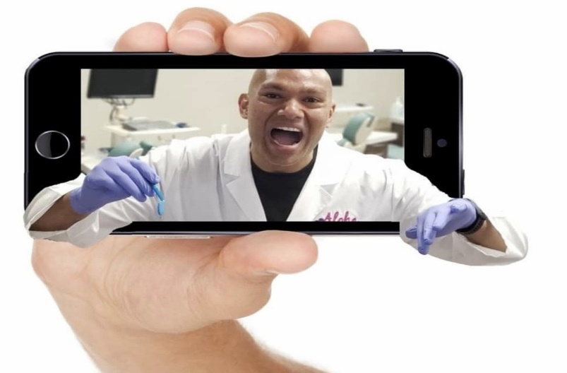
Get your Convenient Virtual Retainer check with Dr. C!

We are offering you a virtual Retainer check to allow you to stay in the comfort of your home while continuing to check the stability of your teeth post braces/Invisalign removal.

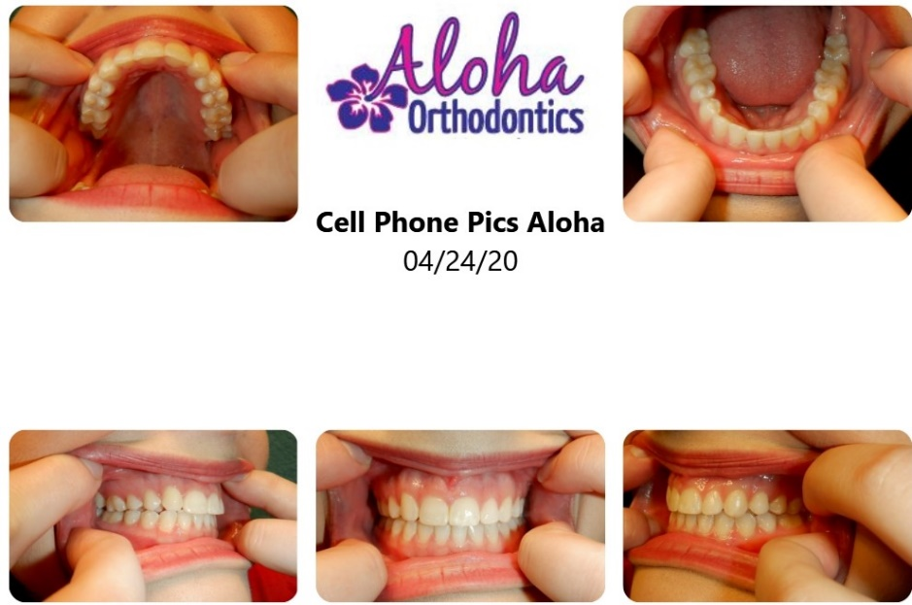

- Take a set of photos of your teeth with your retainer(s) in

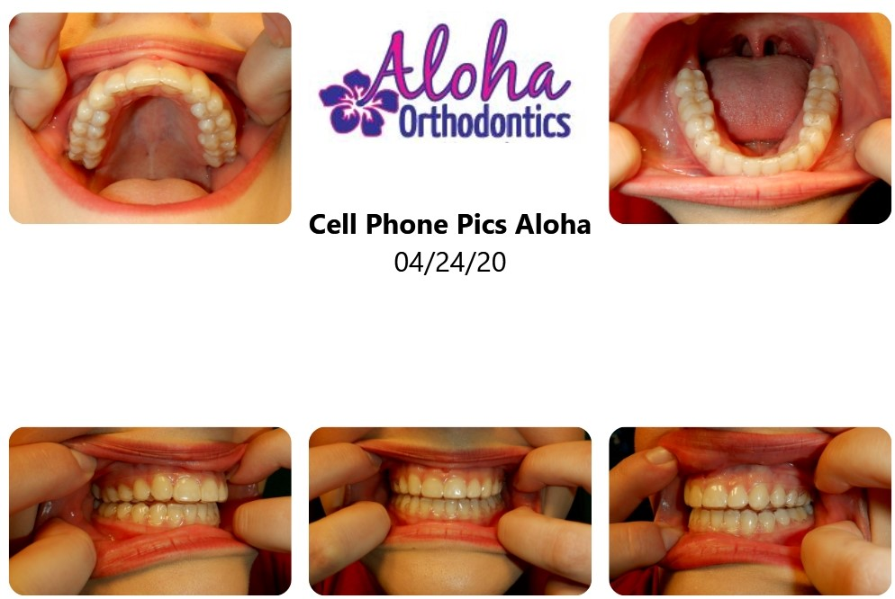

- Take a photo of your retainer(s) over a white piece of paper so we can check the condition of your retainer(s).

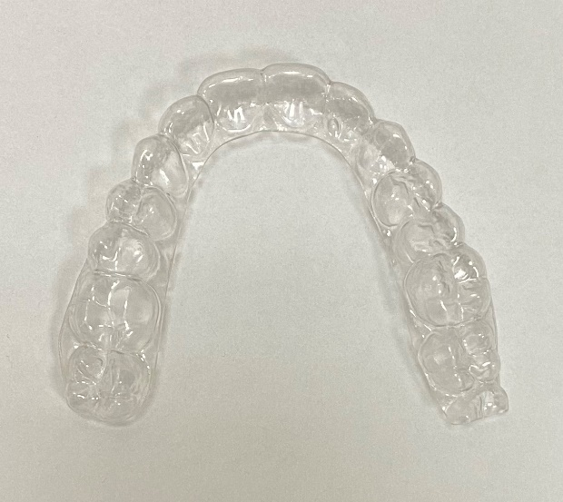
- E-mail your photos for Dr. C to review

- Please Note: Retainer checks are ALWAYS available at no added cost so do not hesitate to schedule an appointment to have Dr. C check if you have any issues with your retainers!

Call: 702-648-2564
E-mail: virtual@aloha-braces.com

