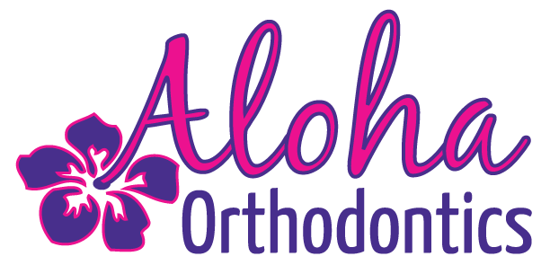

Get your Convenient Virtual Braces check with Dr.C!
We are offering you a virtual Braces check to allow you to stay in the comfort of your home while continuing to progress your treatment.

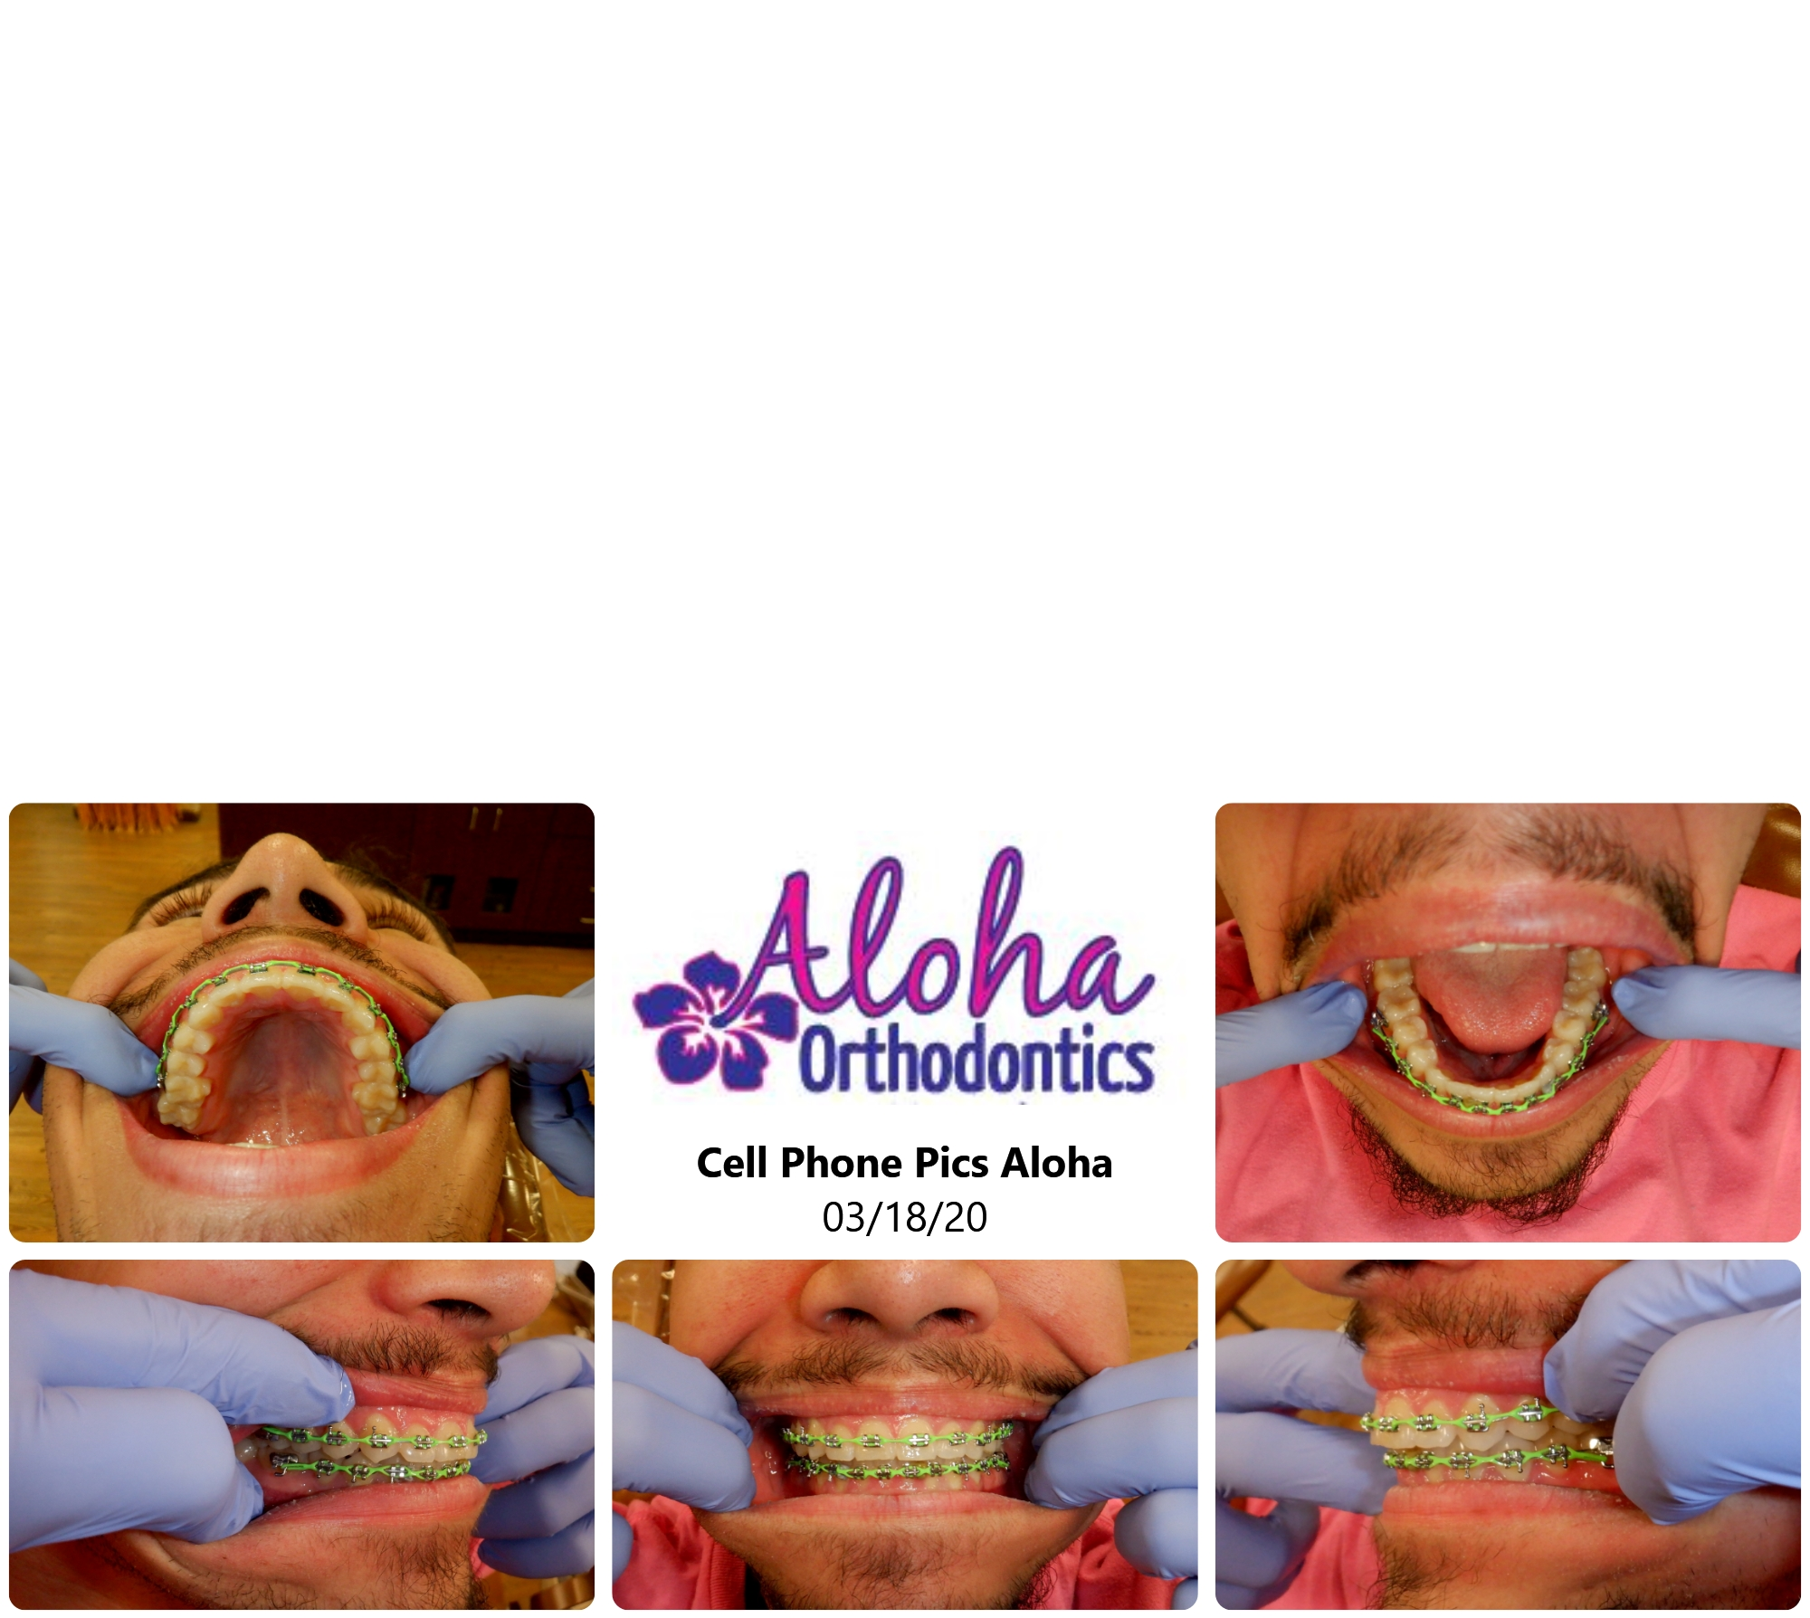

1. Using a smart phone, take a set of photos of your teeth
** Check out our website for an instructional video at:
Aloha-Braces.com **

2. E-mail your photos for Dr.C to review.

3. You will have a virtual appointment scheduled. Please send the photos within the week before or on your appointment date.

4. Our Clinical Director will follow up with you after Dr. C reviews your treatment.

5. Please Note: Braces checks in person are ALWAYS available and recommended if you have any issues so do not hesitate to schedule an appointment to have Dr. C check if you need!
Phone: (702) 648-2564
E-mail: virtual@aloha-braces.com

